 CENTRAL EGLINTON COMMUNITY CENTRE
160 Eglinton Avenue East, Toronto, Ontario M4P 3B5

Telephone: 416-392-0511 Fax 416-392-0514

Email: info@centraleglinton.com
Website: www.centraleglinton.com
FALL NEWSLETTER 2010

IN THIS ISSUE

► Open House…………………………………2
► Events & Fundraisers …………………….3-4
- Annual Auction ……………….3
- Holiday Gift Fair ………………3
► Volunteer Opportunities ………………….5
►Children’s Programs
- Registration Procedures ……….6
- Infant Programs ……………….6-7
- Toddler Programs………..…….8
- Pre-school Programs……..….....9
- School-Age Programs…………9
- Parent/Caregiver Resource Centre…10
- Drop-In hours……………….….15
- Toy Library Hours……….……..15
►Other Services ……………………….…..…14
► Adult Programs
- Dance, Yoga & Fitness ………..16-17
- Languages/Workshops…………18
- Creative Arts…………….…….19
►50+ Programs ……………………….……..20-21
►Computer Lab Programs…………………22
►Advertisers…………………………………23


CENTRE HOURS
Monday through Thursday 9:00 a.m. – 9:00 p.m.
Friday 9:00 a.m. – 4:00 p.m. Saturday 10:00 a.m. – 4:00 p.m.

The Centre closes over the lunch hour

12:30 – 1:30 p.m. on Saturdays

*As of September 7, 2010
Centre hours will change to:
HOLIDAY CLOSURES Monday through Thursday 9:00 a.m. – 9:30 p.m.
Central Eglinton Community Centre Friday 9:00 a.m. – 4:00 p.m.
will be closed to the public: Saturday 10:00 a.m. – 4:30 p.m.
Monday, September 6 – Labour Day The Centre closes over the lunch hour

Monday, October 11 – Thanksgiving 12:30 – 1:00 p.m. on Saturdays
Thursday, November 11 – Remembrance Day

EXECUTIVE DIRECTOR’S REPORT

It was such a beautiful summer! The weather was incredible -- lots of sunshine and warm breezes. Our older adults, our day campers and our Summer-In-The-Park program certainly took advantage of the fabulous weather.

As the days begin to shorten and the nights are cooler, our thoughts turn to autumn and getting back to our routines. Fall is a great time to learn a new skill, take a class and meet new people. Read on to find out about our great fall programs.

Make sure to mark your calendar for our OPEN HOUSE on Tuesday, September 14th from 2:00 p.m. – 7:00 p.m. Come and meet our instructors, see program demonstrations and get information on what’s happening at the Centre this fall.

At CECC fall and auction are nearly synonymous! Join us this year for AUCTION 2010 on TUESDAY, October 19th at MIRAGE (117 Eglinton Ave. East) just across from the Centre. It’s our biggest fundraiser of the year! Our business community supports us with fantastic items for auction and you, our loyal friends and members, support us by attending and getting some great deals! It’s full of fun and a great way to support a very worthy cause. All funds raised go directly to our programs. Bring some friends and make an evening of it! It will be a night to remember!

Before you know it the holidays will be upon us! Jump start your holiday shopping at the
HOLIDAY GIFT FAIR on Friday, November 26th. Join us for lunch or a snack in The Snowflake Cafe or pick up some home baking at the Incredible Edibles table. With lots of local artisans, shopping for that special gift will be a breeze! I hope you will join us!

I look forward to seeing you in our programs and at our special events.



Susan Kee
Executive Director

You’re Invited to Central Eglinton Community Centre’s
2
OPEN HOUSE
Tuesday, September 14,
from 2:00 p.m. to 7:00 p.m.

Are you new to the neighbourhood and wondering what the Centre is all about?
Come in and meet the staff and volunteers and have a tour of our facilities.
Are you a parent or caregiver? We offer Family Resource Programs, including drop-ins and a Toy Lending Library, plus an after-school program for school-age children.
Adults, discover our excellent (and very reasonably priced) classes in Yoga, Belly Dancing, Zumba, Conversational Spanish, Painting and Drawing, and more.
Are you an adult 50+? Come in and check out the many wonderful programs we offer: current events discussion group, bus trips, information sessions, luncheons, outings, computer courses – and more.
Are you looking for volunteer opportunities? Please speak with CECC’s Volunteer Co-ordinator.
If you take out a new CECC membership on September 14, you will receive a free CECC logo water bottle (while supplies last).
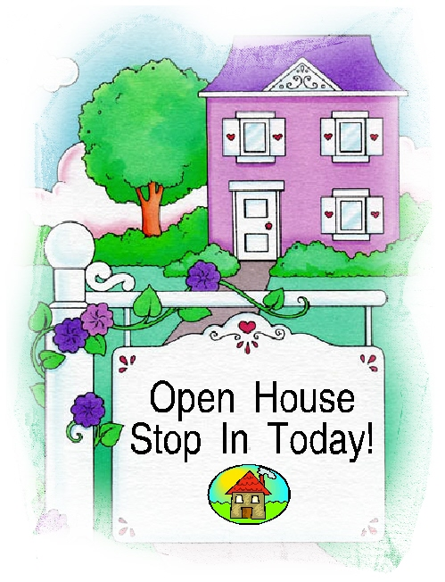
Refreshments provided. Registration is not required. For more information, please phone 416-392-0511, ext. 0. CECC is the place “where new friends meet” since 1976.


Pop/Juice/Snacks FOR SALE at
CECC! Only 75 cents!

Thirsty? Tired of paying for over-priced pop? Just step right up to the CECC fridge and make your selection from a variety of pop, juices, water or snacks. The price can’t be beat! Please pay at the front reception desk.

EVENTS & FUNDRAISERS
3

AUCTION 2010

Tuesday, October 19, 2010
Mirage Grill & Lounge
117 Eglinton Ave. East
Doors open for Silent Auction at
6:00 p.m.
Live Auction starts at 7:00 p.m.


New year – new fabulous location for CECC’s biggest fundraising event!
You’ll find great deals on so many items and services:
- Gift baskets
- Dinners for 2
- Tickets for sports events
- Tickets for cultural events
- Certificates for personal services, such as haircuts, manicures, spa days, massage therapy, etc.
- Certificates from your local pub, grocery store, theatre, etc.
- And more!
It’s a fun night out, it’s for a good cause, and it’s in the neighborhood – come on out and bring your friends!


If you have an item or service that you would like to donate for Auction2010, please contact Nancy at 416-392-0511, ext. 225.
To reserve your table at Mirage for Auction night on October 19, please contact Nancy at 416-392-0511, ext. 225.
If you’re interested in volunteering for Auction 2010, please contact Mary at 416-392-0511, ext.233.

HOLIDAY GIFT FAIR
FRIDAY, November 26, 2010
10:00 a.m. to 2:00 p.m.

This holiday season, are you running out of gift ideas? Tired of shopping at the big impersonal malls? Then visit and stay awhile at CECC’s Holiday Gift Fair on Friday, November 26, where you’ll find new inspiration for your holiday gift list and the personal touch from our many exceptional vendors.
Treat yourself to lunch with friends, and enjoy the CECC holiday tradition of sampling delicious pies in our Pie Baking Contest!
CECC’s Holiday Gift Fair features:
- Fabulous Gift Items and Unique Crafts
- Hot Lunch and Snacks in the Snowflake Café
- Incredible Edibles from the CECC Bake Table
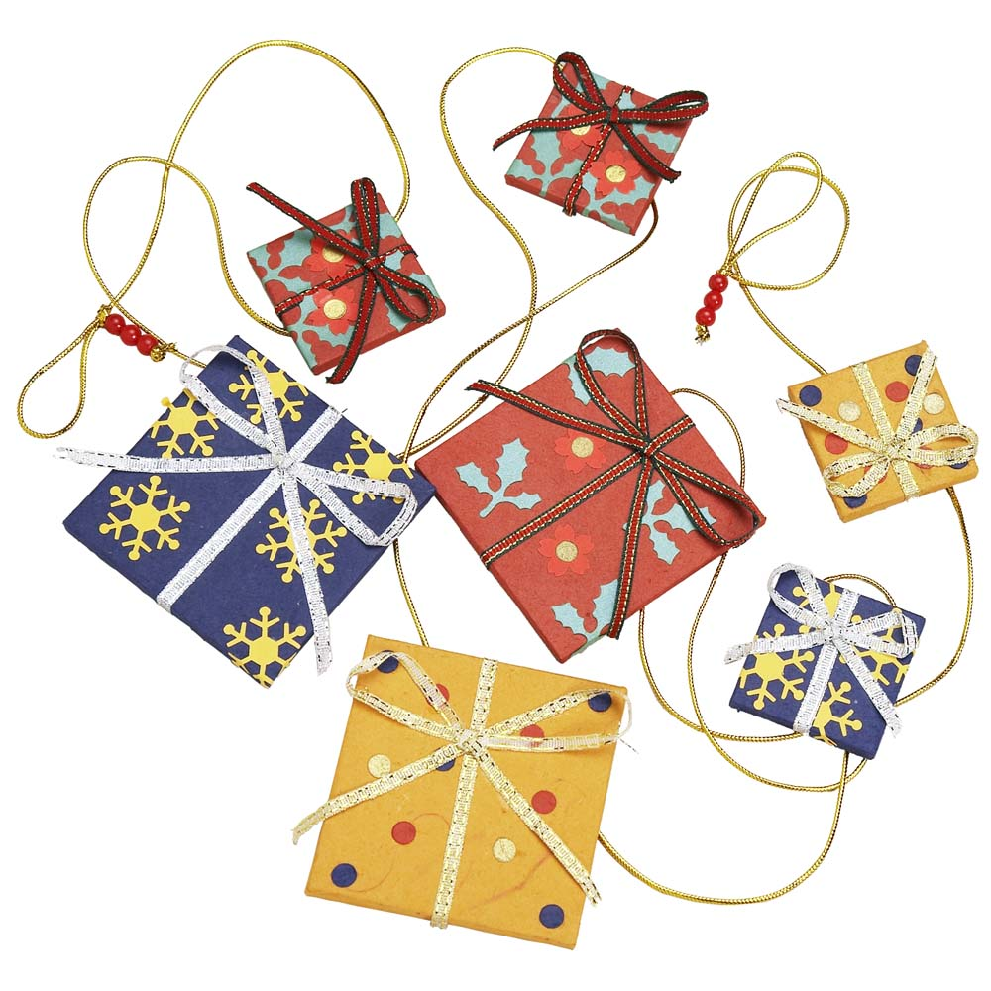
- CECC’s Used Book Room
- Gently-used Holiday Treasures
- Silent Auction
- Door Prizes
- Pie Baking Contest
To rent a table ($25.00) or enter the Pie Baking Contest, please phone Nancy at 416-392-0511, ext. 225.
To volunteer for this event, please phone Mary at 416-392-0511, ext. 233.

TORONTO CHALLENGE JUNE 2010
In spite of a sunny but very humid day, the CECC walking and running team persevered on to the Toronto Challenge finish line on Sunday, June 13. Thank you to the participants and donors who made this one of our most successful years ever, raising funds for CECC’s 50+ Program. Many thanks to all who contributed to this worthwhile and important initiative.

4

4

EVENTS & FUNDRAISERS


It is with great appreciation that
Central Eglinton Community Centre
thanks the following:
- CIBC World Markets Children’s Foundation
- City of Toronto
- City of Toronto Children’s Services
- City of Toronto -Parks, Forestry & Recreation, Major Recreation Partnership Program
- City of Toronto - Social Development, Finance & Administration Division, Community Service Partnerships Program
- Province of Ontario Summer Jobs Service & Youth Employment Service (YES)
- Government of Canada, Human Resources & Skills Development Canada, Canada Summer Jobs
- Ministry of Health and Long-Term Care
- The Toronto Star Fresh Air Fund
- As well as individual donors and businesses who support CECC through the Toronto Challenge and other fundraising initiatives.

Thanks to the following exhibitors for participating in our 8th Annual Health & Beauty Day on June 10, 2010:

Achieve Health/Path to Health, Michelle Weir; Avon, Feanny Xu; Balance Skin Potions, Rosa Milando; Café of Life Chiropractic, Dr. Evan Hill; Corazon Shiatsu, Daniel Pikelin; eMbody Fitness, Johanna Brooks; FLEXaRite, Jackie Kerbel; Isagenix, Bob Williamson; Juice PLUS+, Linda Milthorpe; Let It Heal, Patti Brooks; Lisi217, Lisi Colby; Listro Chiropractic & Massage Clinic, Dr. Paul Listro; Marie and Natie Cosmetics, Natalia Chiu; MD Home Call, Dr Alissia Valentinis; Nikken, Meconnen Desta; Penny Lane Organics, Bo Penny; Perfect Balance Therapies, Sharon Walsh; Sahaja Meditation, Gor Titan; Sterling Design Company, Pat Apostolopoulos; Total Equilibrium, Carolina Gutierrez; Traditional Healing Centre, Jason Tarter; Vibrancy Wellness Products, Liala Epstein; Joshua Zuchter, Life Coaching & Business Consulting.

Thanks to the following for their generous donations and support for our 8th Annual Health & Beauty Day:

Sponsor: Vitality, Toronto’s Monthly Wellness Journal; Downward Dog Yoga Centre; The Arthritis Society; Canadian Cancer Society; Dairy Farmers of Canada (Ontario); Heart & Stroke Foundation of Ontario; Toronto Public Health

CECC FUNDRAISING BOUTIQUE

Check out these items for gift ideas!
*5-Piece Stationery Gift Set $5.00
*BBQ Apron & Set $12.00
Chrome Wire Caddy 2 for $1.00
Cooler Bag $2.00
*Magnetic Message Centre $7.00
Organza Gift Bags 2 for $1.00
*Rain Hat (plaid) – reversible! $4.00
*School/Office Kit $8.00

For the kids! Guaranteed FUN!
Crayola Colouring Mat $5.00
Play & Learn Toy $7.00
–Choose walkman, bear or butterfly!
*Regener8r’s – 8 toys in one! $9.00
Toy Tool Box Set $12.00

For the Garden:
Alpine Wooden Bird Feeder $7.00
Butterfly Feeder (includes food) $2.00
Hummingbird Feeder $3.00
Laughing Face Planter/Fountain $9.00

*These items are available only in very limited quantities.
All proceeds support CECC’s programs & services. All sales are final.

Bring in Your Old Cell Phones to CECC!

This is a fundraising venture for CECC.
Pitch-In Canada is an organization that collects old cell phones which are refurbished to re-use in emerging countries, or cell phones that can be recycled. This is a fundraising venture that is good for the environment! Pitch-In Canada will reimburse CECC for every cell phone we collect.


The Cell Phone Collection Box is located on the ground-floor lobby, to the right of the reception desk.

Thanks for your support!

5

VOLUNTEER OPPORTUNITIES AT
CECC
50+ Program Volunteer Opportunities
Do you have a special skill or talent you would like to share with other CECC 50+ members? The 50+ Program is seeking volunteers to sit on an Advisory Committee, lead a workshop, present a travelogue, or share a skill/talent. Consider sharing what you know with a friendly group!

Decorators
Come help use your imagination for decorating. We have 4 events a year when we need our Centre to look festive. Our first one is the Holiday Gift Fair in November. Decorating would be done on the evening before the event. The next events are our Psychic Fair in April, Spring Bazaar in May, and Health and Beauty Day in June. No training needed, just bring your imagination and your ideas.

Special Event Assistants - We need strong backs and helping hands to help set up and take down for CECC’s community events throughout the year (craft markets, program events, annual general meeting, the auction, and more). You would move furniture/equipment to and from the program room; arrange chairs, tables in the designated program room and help with cleaning up after the event is over; return all furniture/equipment to their original place. Heavy lifting and climbing stairs are involved. A requirement of 2-3 hours commitment is needed for each event.

Income Tax Preparers - If you have some spare time in March and/or April 2011 please consider volunteering as an Income Tax Preparer for CECC’s Income Tax Clinic. We are looking for people who can volunteer at least once per week for a minimum of 4 weeks. Training will be provided to augment your current knowledge of basic income tax returns.

Income Tax Clinic Receptionist - Do you have a pleasant and helpful telephone manner and want to use your customer service experience? From mid-February 2011 until the end of April 2011, we need volunteers to book appointments and make reminder calls for the Income Tax Clinic. Various shifts are available.
Contact: Mary Neeson, Volunteer Co-Ordinator at 416-392-0511, ext. 233 or email
volunteering@centraleglinton.com

*CECC does not participate in Ontario Works (Work Fare) or any similar programs.
DONATIONS TO CECC
5
Central Eglinton Community Centre is a registered non-profit charitable organization (Registration # 11884 3093 RR0001) and thus can issue charitable tax receipts for donations of $10.00 or more.

- Please consider giving to CECC to mark a special occasion, a holiday, or to honour someone on their birthday with a donation in their name.
- Please consider making CECC your United Way Campaign designation. The Centre regularly receives small but significant payments through the United Way from generous folks who made CECC their charity of choice.
- Please consider planned giving. Several long-time members of CECC have made bequests to the Centre in their wills. We are grateful for this support, which is crucial to enhancing our programs. If you are considering planned giving, please discuss it with your family, financial advisor and your lawyer.

“Donate NOW” Button on CECC Website
For your convenience, you can go to the CECC website, www.centraleglinton.com, and make your donation through the “Donate NOW” button, which will take you to the Canada Helps website. This is a fast, easy, secure way to donate (and can even be done anonymously if you prefer). CECC is grateful for all donations and all community support.

RECEIPTS
CECC issues charitable tax receipts for all donations over $10.00. However, when enrolling for programs such as children’s programs, after-school program, March break camp and summer day camp, please retain the fee receipt that is issued
upon registration and payment. CECC does not issue separate receipts for income tax purposes for registration fees.


GET YOUR CECC T-SHIRTS
These cheerful red T-Shirts with
CECC’s logo will make a charming
and useful addition to anyone’s wardrobe. Wear them at fitness classes, over your bathing suit, as night wear – or around the town! Just $15.00 each. Why not buy 2? Sizes available: medium, large and X-large. Buy yours today from CECC!

PARENT/CAREGIVER RESOURCE CENTRE
6

CHILDREN’S PROGRAMS

Unless otherwise noted, all programs begin the week of September 27, 2010 and run for 10 weeks. Current CECC Family membership (expiry date – December 2010 or later) is required for registration in all children’s programs (with the exception of Drop-Ins). Two unrelated children attending programs with one caregiver will be charged separately. Please see the program registration procedure for fall programs below.

REGISTRATION PROCEDURE FOR CHLDREN’S PROGRAMS
FALL 2010

Fill out one registration form and one program choice form per child.

Drop off the forms in the ballot box no later than Tuesday, September 7, 2010 at 9:00 p.m. at CECC.

Registration forms will be picked at random by staff until each class is full. (This is a lottery process.)

Parents will be notified by telephone by September 11–13, 2010.

Full payment is due on or before Wednesday, September 22, 2010 in order to confirm your child’s spot in the class.

INFANT PROGRAMS
Must be accompanied by parent/caregiver

MOM & BABY PILATES
For moms and babies
Ages 6 weeks to 6 months

Every mom needs some help to get back into shape after childbirth. Take advantage of this class at CECC where both you and your baby will have fun while getting fit. Pilates uses movements to strengthen your
core and tighten your abdominal muscles.
The instructor is an experienced Pilates teacher.
2 days & times to choose from!
Session I:
Day: Fridays
Time: 1:30 – 2:30 p.m.
Dates: Oct. 8 - Dec. 3 (8 classes, no class Nov. 26)
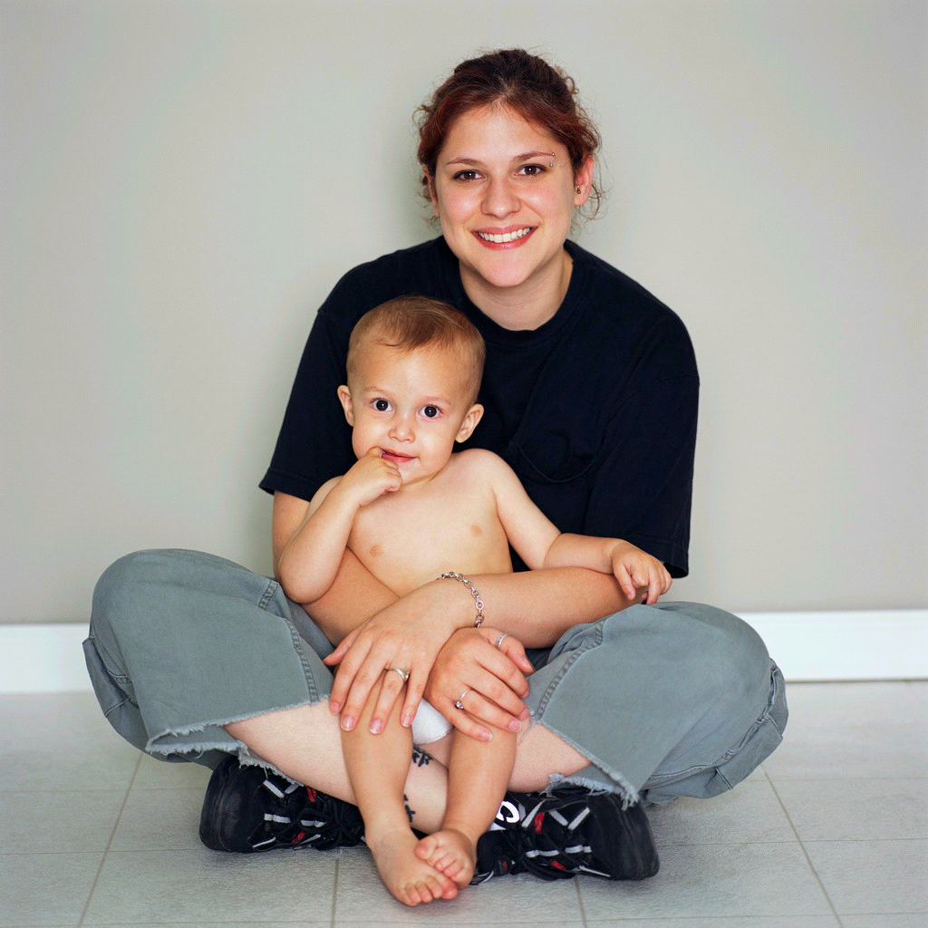
Cost: $67.00
Session II:
Day: Mondays
Time: 10:00 - 11:00 a.m.
Dates: Oct. 18 - Dec. 6 (8 classes)
Cost: $67.00

MUSIC FOR YOU AND YOUR BABY
Ages 4 – 12 months

This structured music time involves participating in active music, learning songs and fingerplays with the use of musical instruments, rhymes, bubbles and a parachute!
Day: Wednesdays
Time: 1:30 p.m. - 2:15 p.m.
Session I: Oct. 6 - 27 (4 classes) - $28.00
Session II: Nov. 3 - Dec. 1 (5 classes) - $35.00
INFANT MASSAGE
Ages 8 weeks – 8 months

Touch is your baby’s first language. Through touch and massage, you can communicate with your baby and help relieve baby’s stress through relaxation. Based on the International Association of Infant Massage, this 5-week program will provide you with hands-on practice using infant massage techniques in a comfortable environment. Please bring a towel, the instructor will provide massage oil.
Jackie Coulter, the owner of Coulter Clinic, is a registered massage therapist and has lived and practiced in North Toronto for over 20 years.
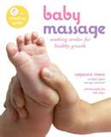
Day: Wednesdays
Time: 10:00 a.m. - 11:00 a.m.
Dates: Oct. 13 - Nov. 10 (5 classes)
Cost: $45.00
(Manual/materials to be purchased through the teacher for $15.00)

BABY’S AFTERNOON OUT
Ages 6 – 12 months
Come join us on Thursday afternoons for socialization, peer interaction and early learning activities with baby. Participate in our weekly discussions on a variety of child-related topics. Activities will include: freeplay, sensory activities, stories, music with instruments and a parachute.
Day: Thursdays
Time: 1:00 – 2:00 p.m.
Date: Nov. 4 – Dec. 2 (4 classes, no class Nov. 11)
Cost: $32.00

7

INFANT PROGRAMS
Must be accompanied by parent/caregiver


BABY ITSY BITSY YOGA
Ages newborn - 6 months

Baby Itsy Bitsy Yoga classes contain dozens of unique yoga postures tailored to your baby’s development. Each class is filled with calming, nurturing ways to enhance bonding and improve baby’s sleep. Babies enjoy yoga while on their backs, tummies, or held in loving arms.
Most of the yoga we will do is for baby, but you will also learn breathing and relaxation techniques as you practice a bit of yoga yourself. No yoga experience is required.
Jennifer Eisberg, RYT, CIBYF, has been teaching yoga to babies and children since 2006, and to adults since 2001. She is the founder and former director of The Santosha School of Yoga, Westminister, Maryland.

Day: Fridays
Time: 9:30 a.m. - 10:15 a.m.
Dates: Oct.15 – Dec. 3 (6 classes,
no class Oct. 29 or Nov. 26)
Cost: $60.00

BABY GYM
Ages 6 - 12 months


This active program is designed to promote and enhance your baby’s gross motor skills. A combination of equipment will be available for use – slides, balls and mats, in a free play format. Staff will be available to suggest different activities that can help strengthen your baby’s muscles and promote healthy development.
Sessions will end each week with a music time that will include songs, finger plays and rhymes.
Day: Thursdays
Time: 1:00 – 2:00 p.m.
Dates: Sept. 30 – Oct. 28 (5 classes)
Cost: $40.00

LIVING AND LEARNING WITH BABY
(6 weeks – 6 months)
A free program provided by Toronto Public Health Nurses.

Come, meet other parents and talk about adjusting to parenthood, infant nutrition, growth & development, caring for a sick child, child safety & community resources. To register and for more information, please call Toronto Public Health at 416-338-7600.


DancinWithBaby®
Ages 6 weeks - 12 months

DancinWithBaby® is a mom and baby dance class that teaches actual dance steps based on the syllabus taught at professional ballroom and Latin dance studios.
This unique 4-week course introduces the steps to the most popular Latin dances in a fun, imaginative and playful way; and is designed so that all the steps learned can be used in any social setting with or without a partner. Plus, it gives moms the opportunity to meet other moms, lose that extra baby weight, and best of all – bond with their baby!

Lola Ilizirov is a Professional Dancer with 25+ years in dancing and performing/competing, a certified dance instructor and a member of the CDTA (Canadian Dance Teachers Association).
Day: Fridays
Time: 12:00 noon - 12:45 p.m.
Session I: Oct 8 - 29 (4 classes)
Session II: Nov. 5 – Dec. 3 (4 classes, no class
Nov. 26)
Cost: $45.00 per session

TRIP TO PUCK’S FARM Parents/Caregivers & Children
(1 – 5 years*)

Thursday, September 23
9:30 a.m. – 2:30 p.m.
COST: Adult: $16.00, Children: $13.00
(all prices include bus, admission to
Puck’s Farm and all activities)

We’re on the way, we’re on the way, on the way to Puck’s Farm! Just north of Toronto in Schomberg (near Newmarket), Puck’s Farm will surely delight the child in each of us. Puck’s Farm is the place to meet barnyard animals, relax on a horse-drawn hayride, enjoy a guided barn tour, pumpkin picking, and pony rides. Make sure to bring a litter-less picnic lunch as there won’t be any food available for purchase.

We will be travelling by school bus. Please bring an umbrella type foldable stroller only.

PLEASE ARRIVE AT CECC NO LATER THAN
9:15 a.m. TO BOARD THE BUS.
*please note, children need to be at least 1 year+ for the bus.

8

TODDLER PROGRAMS
8
Must be accompanied by parent/caregiver

ENJOYING YOUR TODDLER
Ages 1 and 2 years

Participate in the development of your child’s active socialization, fine and gross motor skills and creativity. This interactive, structured program runs Mondays and Wednesdays. Activities include: free play, arts and crafts, sensory activities, snack, music with shakers, a parachute, and more! Siblings under the age of one may accompany their parent/caregiver. You may register for 1 or 2 days per week.
Day: Mondays – Sept. 27 - Nov. 29
(9 classes, no class Oct. 11)
Wednesdays - Oct. 6 - Dec. 1

(9 classes)
Time: 9:30 - 11:30 a.m.
Cost: $86.00 - Mondays
$86.00 - Wednesdays

TERRIFIC TWOS
Ages 2 years

Help your child become more independent with the goal of attending programs on their own. Join in on circle time, crafts, sensory/science, cognitive/language activities in a co-operative environment. There will be opportunities available to leave your child in the care of other program participants for part of the program.

Day: Tuesdays
Time: 9:30 - 11:00 a.m.
Dates: Sept. 28 - Nov. 30 (10 classes)
Cost: $80.00

CHILD EMERGENCY

WORKSHOP

DATE: Saturday, October 23
TIME: 9:00 a.m. – 3:30 p.m.
COST: $67.00 (includes manual and H.S.T.)

Become certified in Infant/Child CPR and First Aid. Learn how to treat and prevent common child related injuries such as choking, allergic reactions, falls and seizures. Certificates will be given out at the end of the class.
Please contact Leanna at 416-392-0511, ext. 246 for more information.

TODDLER MUSIC & GYM!
Ages 15 months – 2-1/2 years

Join your toddler in a structured music circle learning new songs and fingerplays, using musical instruments, a parachute & more! A gym time with balls, climber, riding toys, tunnels, & active play will end each class.

Day: Thursdays
Time: 9:30 - 10:30 a.m.
Dates: Sept. 30 - Dec. 2
(9 classes, no class Nov. 11)
Cost: $63.00
TYKES ITSY BITSY YOGA
Ages 21 months - 4 years (accompanied by parent/caregiver)

Tykes Itsy Bitsy Yoga combines unique toddler-friendly Yoga poses with songs, stories, and games to create an enriching parent/child activity. Each class is personalized around your tyke’s curiosities as they learn yoga through social interaction, repetition, and play. Tykes also learn how to relieve frustration, improve motor skills, and increase attention span by actively following directions. No yoga experience is required.
Jennifer Eisberg, RYT, CIBYF, has been teaching yoga to babies and children since 2006, and to adults since 2001. She is the founder and former director of The Santosha School of Yoga, Westminister, Maryland.

Day: Fridays
Time: 10:30 a.m. - 11:15 a.m.
Dates: Oct.15 – Dec. 3 (6 classes,
no class Oct. 29 or Nov. 26)

Cost: $60.00

STROLLER PARKING/CHILD MONITORING
Due to fire and safety regulations, all strollers/carriages must be parked in the designated area only in the lobby, giving free and unobstructed access to ramps and stairwells.
No child, sleeping or awake, may be left unattended in the Centre.
Staff cannot assume responsibility for monitoring or supervising any child.

PRE-SCHOOL PROGRAMS
Designed for children to participate
on their own

PEANUT CLUB
Ages 2-1/2 - 4 years
(This is a drop off program)

This is a structured program designed for children ages 2-1/2 – 4 years to experience a social group setting on their own. Activities include arts and crafts, music, stories, snack and much more.
You may choose 1 or 2 days per week.
Day: Mondays, Tuesdays, Wednesdays, Thursdays
Time: 9:30 - 11:30 a.m.
Dates: Sept. 27 - Dec. 2
Cost: Mondays: $99.00 (9 classes, no class Oct. 11)
Tuesdays: $110.00 (10 classes)
Wednesdays: $110.00 (10 classes)
Thursdays: $99.00 (9 classes, no class Nov. 11)

KID FIT
Ages 2-1/2 - 5 years
(If children are not toilet trained, parent/caregivers

need to participate)
Eating healthy, exercising and fun all go together in this program. Children will engage in gross motor activities using balls, hoops, beanbags and shakers. Participants need to wear comfortable clothing, running shoes, bring a water bottle and be prepared to have active fun.
Susan Poss is a former kindergarten teacher with many years of experience and has been working with children for more than 20 years.
Day: Mondays
Time: 4:00 p.m. - 4:45 p.m.
Dates: Sept. 27- Nov. 29 (9 classes, no class Oct. 11)
Cost: $74.00


SPORTS FUN

Ages 2-1/2 – 4 years
(Children must be toilet trained)
(This is a drop off program)
Join in the fun while learning soccer, tennis and fitness in an active and energetic program. Using drills and exercise instructions, children will learn in a fun and safe environment. This is a great way to get children started in sports.
Canadian Sports Academy instructors are police screened and have “special training” in teaching sports to children.
Day: Thursdays
Time: 3:00 – 4:00 p.m.
Dates: Oct. 7 – Dec. 2 (8 classes, no class Nov. 11)
Cost: $95.00

PRE-SCHOOL PROGRAMS
9

KINDERMUSIC Ages 2-1/2 – 4 years
(If children are not toilet trained, parent/caregivers need to participate)
Enhance your child’s skills and awareness of music through the use of singing and percussion, rhythm and music games. Children will participate in storytelling, drama and movement in a joyful, creative atmosphere.

Marcia Acker is an experienced musician/teacher who has studied Orff pedagogy at the Royal Conservatory of Music.
Day: Fridays
Time: 10:00 – 11:00 a.m.
Dates: Oct. 1 – Dec. 3 (8 classes - no class Oct. 29 & Nov. 26)
Cost: $77.00

SCHOOL AGE PROGRAMS

MUSIC MAKERS: AROUND THE WORLD

Ages 5 - 7 years
Children will participate in singing, ear training, playing instruments, ensemble work and creative movement activities. Students explore the music of other cultures, including American-Indian, African-American, British, and German music. This course enhances cultural awareness, helps children develop their listening and vocal skills, move towards becoming musically literate, and gain control of their bodies. Additionally, this course accentuates higher-level skills such as symbolic thinking, concentration, memory, and self-expression skills.
Sarah Barry is a passionate, dedicated musician and educator who believes in music and every child deserves the best possible education in music. Sarah has a B.A. (Hons) and a B.Ed. from York University with a Specialty in Music, and has trained with the Royal Conservatory of Music.
Day: Mondays
Time: 4:00 - 4:45 p.m.
Dates: Oct. 18 - Dec. 6 (8 classes)
Cost: $65.00
THE PAL-O-MINE CLUB
After-School Program

Tuesdays, Wednesdays, and Thursdays from 3:30 to 6:00 p.m.
Tuesday, September 7, 2010 – June 2011
Sign up for one, two or three days per week ($7.00 per day, $20.00 per week, per child).
A structured yet flexible schedule of play, homework help, club activities (cooking, arts & crafts, games, music) and snack. Please come into the Centre to register, or phone Nancy at 416-392-0511, ext. 225 for more information and for information about school pick up. (Not a lottery process.)
Last year, CECC staff picked up students from Eglinton Public School and John Fisher.
Funded by City of Toronto Major Recreation Partnership Program

TUESDAY MORNING SPEAKERS SERIES

Join us for free information sessions/workshops on Tuesday mornings designed with parents, caregivers and children in mind. Children are welcome at the sessions! For more information, please contact Leanna at 416-392-0511 ext. 246.

Making Your Own Baby Food
Presented by Kanthi from Food Share
October 5 & Nov. 9 @ 10:00 a.m.
Do you want to make your own baby food but aren’t sure how? Join us for this workshop! Babies are welcome to attend.

Photo Solutions Demo
Presented by Sandra Northmore
October 19 @ 10:00 a.m.
Enjoy the fun at this Photo Solutions Demo where you will learn how to take better pictures and learn how to get photos from your camera into beautiful photo albums and displays in less time than you ever thought possible.

Financial Planning Check up
Presented by Mark Van Graft, Investment Consultant, Investor’s Group Financial Services
October 26 @ 10:00 a.m.
Join Mark as he discusses how to set realistic financial goals and prepare a budget. Learn more about insurance and pension plans, and how to check up on your financial planning needs.

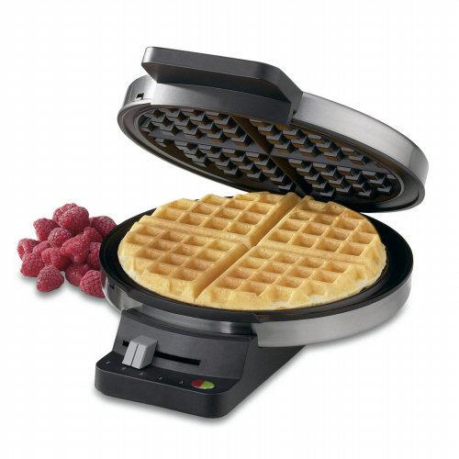
Residential Fire Safety
Presented by Marla Friebe, Public Educator, Toronto Fire Services
November 16 @ 10:00 a.m.
Join us for an informative session about keeping safe at home, fire safety plans, residential fire extinguishers and more.

From Language to Literacy
Presented by Dave Page, Early Literacy Specialist for Ontario Early Years Programs.
November 30 @ 10:00 a.m.
In this fun and interactive workshop, Dave will engage us in a discussion on child language development. We will discuss how rhymes, songs, and stories promote language skills and look at some beautiful, top quality books for young children.

Choosing Childcare
Presented by Leanna Tuba B.A., B.Ed, R.ECE
Family Resource Centre Co-ordinator, CECC
December 7 @ 10:00 a.m.
Join Leanna for an informative session about choosing childcare. She will discuss all aspects of hiring a nanny/caregiver, childcare centres, and home care.
10

PARENT/CAREGIVER RESOURCE CENTRE

NATIONAL FAMILY WEEK BREAKFAST

Friday, October 8
9:30 a.m. – 12:00 noon

Join us for a nutritious breakfast to
start the day right! Stay for
circle time at 11:00 a.m.


CECC’S 8th ANNUAL
HALLOWEEN CARNIVAL
Friday, October 29,
9:30 a.m. – 11:30 a.m.

Join us for our 8th Annual Halloween Carnival featuring games, activities, face painting, refreshments & much more!
Only $7.00 per child for all activities and refreshments!
Suitable for children 12 months+

WAFFLE BREAKFAST
Friday, November 12
Beginning at 9:30 a.m.
Join us for freshly made waffles, syrup, fruit and juice
$3.00 per plate
ALL PROCEEDS BENEFIT CECC’s FAMILY
RESOURCE CENTRE

CECC’S HOLIDAY PARTY

For parents/caregivers
and children

Friday, Dec.17, 9:30 a.m. – 12:00 noon

Join in on holiday crafts,
refreshments and fun!

SERVICES OFFERED AT CENTRAL EGLINTON COMMUNITY CENTRE
14

What else do we do here at Central Eglinton Community Centre, beside provide high quality, affordable programs for our community to enjoy? CHECK THESE OUT!


CHILDREN’S CLOTHING CLOSET


Come and browse our selection located
in the Toy Library. Take clothes that you need
for your child. You may also donate clothes for children ages newborn to size 5 that are clean and in good repair and are no longer needed.
Open Monday – Friday 10:00 a.m. -12:00 noon and 1:00 p.m. - 3:30 p.m.
Monday & Thursday 5:30 p.m. - 8:00 p.m.
Open Saturday 10:15 a.m. -12:00 noon
1:30 p.m. - 3:30 p.m.

CHILDCARE REGISTRY
Babysitters, caregivers, and parents seeking childcare have listed their names in our directory.
To view the binder, please ask at reception during office hours. CECC cannot assume responsibility for screening names in the registry.

HASSLE FREE, FUN FILLED
BIRTHDAY PARTIES

Rent a room for your child’s party!
We have toys galore!
Cost: $50.00 CECC members,
$60.00 non-members
Available: Saturdays, 1:30 – 3:30 p.m.
Call 416-392-0511, ext. 224 for more details.
After September 7, 2010, the Birthday Party room will be available from 1:00 p.m. to 4:00 p.m. and the cost will be
$60.00 members, $70.00 non-members.

FREE LEGAL ADVICE CLINIC
Central Eglinton Community Centre offers a Free Legal Advice Clinic, on Wednesdays between 4:00 and 6:00 p.m. BY APPOINTMENT ONLY. Lawyers Zeenath Zeath and Mbuso G. Nkosi will offer 20 minutes of free legal consultation. Please call 416-392-0511, ext.0 to book your appointment.
COMMUNITY BULLETIN
BOARD

We have a board just inside the doors of the Community Centre that is loaded with community information. You can find job postings, items for sale, free seminars offered and much, much more. Check it out next time you are in the Centre.


FOOD BANK BOX

Do you have a little extra that you
would like to share with your community?
Drop off your donations just inside the Community Centre doors. If you are in need, come in and help yourself.

COMPUTER LAB DROP-IN AT CECC
No reservations! No membership fee!
Pay what you can!
(Suggested donation: 50 cents)
8 computers with high-speed internet access!
Drop-in hours: Monday through Thursday afternoons, 1:00 – 4:00 p.m.
Cost for printing just 20 cents per page.
Phone 416-392-0511, ext. 0 for more information.

FREE FINANCIAL PLANNING CLINIC

Free financial advice is available by appointment at CECC. An Investment Advisor/Chartered Accountant will provide advice on your tax, estate, insurance and investment concerns, RRSP, RRIF and other issues.
Call 416-392-0511, ext. 0 to arrange a 45-minute appointment.

CECC’s USED BOOK SALE
In the front lobby of CECC are hundreds of books and magazines, all for sale. Paperbacks are just 50 cents, hardcover books are $1.00, and magazines are just 10 cents. Sure, the library is free, but if you are going on holiday or just curling up for a quiet evening, spending 50 cents on a book that you don’t have to worry about is a great deal! Check out the variety of material. You won’t go home empty handed! Many thanks to all who have donated these items to CECC for this fundraising effort.

PARENT/CAREGIVER RESOURCE
LIBRARY

Located in the Toy Library, our Resource Library consists of books and videos providing information about child care, stress management, childbirth, child development, and behaviour management.
Books and resources may be borrowed through our Toy Library program.
Please feel free to browse when the Library is open.

PARENT/CAREGIVER RESOURCE CENTRE
15

DROP-IN PROGRAMS
For children ages newborn to 5 years accompanied by parent/caregiver

Drop-ins are FREE for CECC members only.

You must bring your valid Centre membership card each time you attend, and record your membership number on the Drop-in sign-in list.

We will be happy to provide you with an extra membership card if necessary.
These informal and unstructured programs provide parents and caregivers with the opportunity to meet other families in the community. Registration and CECC membership are not required for participation in drop-in programs.
In order to maintain a safe and pleasant environment, CECC reserves the right to limit the numbers of families in drop-ins to a maximum of 20 parents/caregivers, first come, first served.
Parents/caregivers are responsible to assist in
clean up. Let’s keep your CECC tidy.

Cost: $2.00 per family per visit or visit FREE with a valid CECC membership.

Mondays 1:30 – 4:30 p.m.

Tuesdays 1:30 – 4:30 p.m. 5:30 – 7:30 p.m.

Wednesdays 2:30 – 4:30 p.m.

Thursdays 2:30 – 4:30 p.m.

Fridays 9:30 a.m. – 12:00 noon

Saturdays 10:15 a.m. – 12:00 noon
(Drop In will be closed on Oct. 29 for the Halloween Carnival and Nov. 26 for the Holiday Gift Fair)


Scholastic Book Club

Here’s your chance to purchase high quality
children’s books at fabulous prices.
Look for Scholastic Book Club flyers at CECC for your best deals on children’s favourite stories.
For more information, please contact Leanna at 416-392-0511, ext. 246.

CECC’s TOY LENDING LIBRARY

Choose from educational toys, books, drama accessories, games, videos and parent resources. Membership is included in your annual CECC family membership.
Parents/Caregivers can:
- Borrow toys, books, videos, games and parent resources for two weeks at a time.
- Get to know other caregivers and children and share experiences.
- Take a look at our parenting and caregivers’ resources.
- Use our Kids Desk child friendly computer program.
Toy Library Hours:
Mon. 10:00 a.m. – 12:00 noon; 1:00 to 3:30 p.m.
& 5:30 to 8:00 p.m.
Tue. 10:00 a.m. – 12:00 noon; 1:00 to 3:30 p.m.;
& 5:30 - 8:00 p.m.
Wed. 10:00 a.m. – 12:00 noon; 1:00 to 3:30 p.m.
Thu. 10:00 a.m. – 12:00 noon; 1:00 to 3:30 p.m.
& 5:30 to 8:00 p.m.
Fri. 10:00 a.m. to 12:00 noon & 1:00 to 3:30 p.m. *
Sat. 10:15 a.m. to 12:00 noon & 1:30 – 3:30 p.m.
*The Toy Library will be closed Oct. 29 (Halloween Carnival) and Nov. 26 (Holiday Gift Fair)
Please note….Toy Library users are responsible for tidying up the library before leaving.

Toy Library members – please note:
- No child can be left unattended in the Toy
Library.
- It is the responsibility of parents and caregivers
to supervise their child(ren).
- Toys will be accepted for returns only during the
Toy Library hours.
- Toys returned when the Toy Library is closed
remain the responsibility of the member until
the Toy Library re-opens.
- Fines of 10 cents per toy per day will be charged
for overdue toys.
Need to quickly check your e-mail or visit a website? The Toy Library has a computer that you can use while supervising your children. Printing charge is 20 cents per page. Questions? Call Leanna at 416 392-0511, ext. 246.

16

COMMUNITY PROGRAMS FOR ADULTS 18+
16

Please come into the Centre to register, or phone 416-392-0511, ext. 0 to register by phone. Classes require a minimum number of participants in order to run. Please note:
- There are NO REFUNDS for withdrawals from Community Programs.
- If you are unsure of the program’s suitability, you are welcome to visit the first scheduled class at no charge (subject to space availability). If you decide to register for the program after the first class, you would then pay the full program fee.
- This first free visit offer does NOT apply to any Workshops, Artificial Flowers, Cross-stitch, Stretch & Strength, Yoga or Zumba.
- You are welcome to participate in the first scheduled Yoga or Stretch & Strength class for $5.00 (subject to space availability).
- If you decide to register for Yoga or Stretch & Strength after the first class, you would then pay the full program fee less $5.00.
- No free visits will be allowed after the first scheduled class.
- Drop-ins will be allowed after the first scheduled class only for Kung Fu Core Fitness, Stretch & Strength, Yoga and Zumba classes, at a cost of $10.00 per class and subject to space availability.
For more information, please phone Nancy at 416-392-0511, ext. 225, or e-mail programmanager@centraleglinton.com.

DANCE, YOGA AND FITNESS

BELLY DANCING: 3 CLASSES
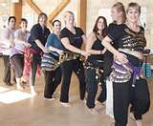
Have fun while you move to the music of Belly Dancing! Belly Dancing can increase your muscle strength and flexibility, as well as improve your posture and enhance body awareness. These classes will introduce you to, or continue your instruction in, the ancient yet modern art of Egyptian Belly Dance. Bring a scarf to tie around your hips and wear exercise clothes. We will dance barefoot or in ballet shoes. Classes are limited to 12 participants.

Belly Dancing is taught by Fayrouza (Jackie Coulter), who studies with one of the foremost performers and teachers of Egyptian Belly Dance in Toronto, Badia Star. Jackie Coulter (Coulter Clinic), is a registered massage therapist and has lived and practised in North Toronto for over 20 years.
CLASS FOR OLDER ADULTS (50+):
Date: Mondays, Sept. 20 - Dec. 13
(12 classes, no class Oct. 11)
Time: 5:00 - 6:00 p.m.
Cost: $85.00 CECC members,
$90.00 non-members
ADVANCED CLASS (all ages):

Date: Mondays, Sept. 20 - Dec. 13
(12 classes, no class Oct. 11)
Time: 6:15 - 7:30 p.m.
Cost: $90.00 CECC members,
$95.00 non-members
BEGINNERS’ CLASS (all ages):
Date: Thursdays, Sept. 23 - Dec. 16
(12 classes, no class Nov. 11)
Time: 6:15 - 7:15 p.m.
Cost: $85.00 CECC members,
$90.00 non-members

Soft Kung Fu Core Fitness &
Energy Work Class
This fitness program is an anaerobic set of movements accompanied with a traditional style of breathing that helps to encourage and sustain many health benefits, both external and internal. These exercises will work to strengthen your core, as well as help with blood flow, energy and oxygenation to every cell in the body, enhancing mobility, strength and the healing capability in the body and mind. The movements can be done at your own pace and are easy to remember, and can be practiced at any age or fitness level, and can also be adapted for most disabilities.
Date: Wednesdays, Sept. 29 - Dec. 1 (10 classes)
Time: 7:30 – 8:30 p.m.
Cost: $70.00 CECC members, $75.00 non-members
Carey Stone is the owner of Tiger Dragon Kung Fu School. He has trained under several Grand Masters and has been teaching Shaolin and Kempo Kung Fu since 2002. Carey learned Taoist Tai-Chi style in 2004 for its health benefits.

ZUMBA®

Get in shape with a party instead of a workout! Zumba® is a Latin-inspired, dance/fitness class that combines Latin music and dance movements to create an effective fitness system. Zumba® integrates aerobic and resistance training to maximize cardiovascular and muscular benefits. Dancers and non-dancers alike easily master a Zumba® class. All students feel great knowing they can just go with the flow and have fun!
Shelly Findlay is a certified Fitness Instructor Specialist with Can-Fit-Pro and a certified Zumba Instructor. She has been trained in ballet, jazz, belly dancing and ballroom dance.
NOTE: Participants will be required to complete a health questionnaire. Admittance to this class is at the discretion of the instructor. Space is limited.
Date: Thursdays, Sept. 23-– Dec. 2
(10 classes, no class Nov.11)
Time: 7:30 – 8:30 p.m.
Cost: $85.00 CECC members, $90.00 non-members,
DEADLINE FOR REGISTRATION: September 16

17

DANCE, YOGA AND FITNESS CONTINUED


YOGA Monday Evening

Instructor: Toni
Yoga will increase flexibility, tone your muscles and improve circulation, enhancing both your physical and mental well-being. An excellent way to energize for the rest of your week!
Date: Mondays, Sept. 20 - Dec. 13
(12 classes, no class Oct. 11)
Time: 7:45 – 8:45 p.m.
Cost: $108.00 CECC members, $113.00 non-members

YOGA Tuesday Lunch Time
Instructor: Toni
Yoga stretches which promote both physical and mental health, through mat work, breathing and standing postures.
Date: Tuesdays, Sept. 21 - Dec. 14 (13 classes)
Time: 12:00 noon – 1:00 p.m.

Cost: $117.00 CECC members,

$122.00 non-members

STRETCH & STRENGTH

Wednesday After Work

Instructor: Brigitte
Stretch & Strength is a combination of Pilates, Yoga and Stretching. This class is a total body workout. If you're looking to sculpt every inch of your body, tone/strengthen your core, and improve your flexibility - this is the class for you! Adding this class to your weekly work-out routine will boost your stamina and agility!
Date: Wednesdays, Sept. 22 - Dec. 8 (12 classes)
Time: 6:00 p.m. - 7:00 p.m.
Cost: $108.00 CECC members, $113.00 non-members

YOGA Saturday Morning
Instructor: Terri-Louise
This Yoga class will include some fundamentals of Pilates to strengthen your abdominal muscles, your back, arms and legs. The movements and postures of Yoga will stretch, tone and relax, while Pilates exercises will help to develop a leaner physique.
Date: Saturdays, Oct. 2 - Dec. 11 (11 classes)
Time: 11:00 a.m. – 12:00 noon
Cost: $99.00 CECC members,
$104.00 non-members

Ballroom Dancing – Intermediate/Advanced
This is a course for students who have already taken beginner courses in Ballroom Dancing. In this course we will continue to work on steps, lead/follow and timing of the Foxtrot, Waltz and Tango.
Date: Tuesdays,
Session I: Sept. 21 - Oct. 26 (6 classes)
Session II: Nov. 2 - Dec. 7 (6 classes)
Time: 6:30 - 7:30 p.m.
Cost: $75.00 CECC members,
$80.00 non-members, per session

Latin Dancing – Intermediate

This is an on-going intermediate class designed for those who have already taken Latin Dancing Beginner courses in Rumba, Cha Cha, Salsa and Samba. Emphasis is placed on lead/follow, new steps, technique and Latin hip movement.
Date: Tuesdays,
Session I: Sept. 21 - Oct. 26 (6 classes)
Session II: Nov. 2 - Dec. 7 (6 classes)
Time: 7:45 p.m. – 8:45 p.m.
Cost: $75.00 CECC members,
$80.00 non-members, per session

Latin Dance for the Absolute Beginner No Partner Required!

If you’ve always wanted to learn how to dance but never had the opportunity, now’s your chance! No partner required! This class will teach you the basic frame, steps and movements to the most popular Latin dances: Salsa and Merengue. Dancing is becoming more popular everyday and this course will teach you how to dance at social events in no time. Wear comfortable shoes without rubber soles.
Date: Saturdays,
Session I: Sept. 18 – Oct. 23 (6 classes)
Session II: Oct. 30 – Dec. 4 (6 classes)
Time: 2:00 p.m. – 3:00 p.m.
Cost: $75.00 CECC members,
$80.00 non-members, per session
Lola Ilizirov is a Professional Dancer and Certified Instructor in American/International Style Latin and Ballroom. She has been performing and competing for over 20 years and currently teaches out of the Joy of Dance Studios. Lola also teaches her DancinWithBaby® course at the Centre.

WORKSHOPS


HOW TO BUDGET YOUR MONEY &
GET OUT OF DEBT!
Presented by Credit Canada (a not for profit charity since 1966)
www.creditcanada.com
We are living in difficult economic times. You are not alone if you are worried about your credit card debt or are having a tough time making ends meet. Come to this free seminar and get information that will help you deal with your financial situation. Please phone 416-392-0511, ext 0, to register.
Date: Thursday, September 16
Time: 6:00 p.m.
Cost: FREE!

HOME-MADE SPA! Workshop
Don’t like lemon, mint or almonds? You will now, and love yourself too in Laura Dee’s amazing creative Home-Made Spa workshop. Strawberry lotion… bath salts – these are just some of the spa products you will make in this workshop. You will also learn to make a homemade face wash, lotions and other goodies, AND take home all of the products you make!
Materials included. Pampering included! Two sessions to choose from!
Date: Session I: Saturdays, Sept. 25 - Oct. 16
(4 classes)

Session II: Saturdays, Oct. 30 - Nov. 20
(4 classes)
Time: 11:00 a.m. - 12:00 noon
Cost: $100.00 per session
21
(Includes all materials and HST)

Bead-AFUL! Workshop
Laura Dee looks forward to bringing new projects to inspire you, from funky jewelry, Hallowe’en surprises, fall and holiday bead craft, as well as necklaces, rings, mobiles and more! Exciting beads, crystals, fishing line, clasps and other fun tools. Projects can include earrings, bracelets, dog tags, holiday ornaments, and more.
Materials included. The best part is wearing what YOU make!
Date: Wednesdays, Oct. 27 – Nov. 24 (5 classes)
Time: 7:00 – 8:00 p.m.
Cost: $95.00 (Includes all materials and HST)
Laura Dee (Laura D'Souza) is a professional designer, calligrapher and mixed media artist. She works with both children and adults and currently retails her original line of jewellery in select boutiques in North America and Europe.

“KNOWING & LOVING
18

YOUR CORE SELF” Workshop
Essentials for Your Personal Growth & Development
Group Coaching Program
Date: Wednesdays, Sept. 29 - Oct. 20 (4 weeks)

Time: 7:00 - 8:30 p.m.
Cost: $145.00 (includes HST)
What this program will cover;
- What Self-Esteem is and Its Importance
- Taking Care of Your Body
- Believing in Yourself
- Acknowledging Your Strengths
- Loving Yourself Unconditionally
You will receive four weekly group coaching sessions. The program comes with a short workbook that will be handed out at the first session.
Please note, spaces are limited. Registration deadline: Wednesday, September 22
This coaching program will be led by Helen Roditis, a certified personal development and leadership coach, and founder of essence coaching.

LANGUAGES/OTHER

CONVERSATIONAL SPANISH

Would you like to have the opportunity to acquire the basic skills for listening and communicating in Spanish in a useful manner day to day? This conversation program provides you with this opportunity. You are invited to learn conversational Spanish in a small group, and improve your skills in a friendly environment.
Date: Tuesdays, Sept. 28 –Nov. 9
(7 classes, 10 hours of instruction)
Time: First class: 6:30 – 7:30 p.m.;
remaining 6 classes: 6:30 – 8:00 p.m.
Cost: $65.00 CECC members, $70.00 non-members
22

INTRO TO MEDITATION
Meditation is an effective technique towards clarity, balance, awareness and renewal. This 6-week course will be a good foundation to take with you in your daily life and personal practice. It is designed in completion including warm ups, awareness, breath, sound and reflection with a mindfulness approach. Participants will learn how to set up their meditation practice and receive notes of the meditation sets after each class, as well as get any questions answered to overcome the myths to meditation on and off the mat.
Gentiana has practiced different meditation techniques for nine years and is a Yoga Alliance registered teacher. Her approach is based on bringing clarity with a focus on mindfulness.
Dates: Wednesdays, Oct. 27 – Dec. 1 (6 classes)
Time: 7:00 – 8:00 p.m.
Cost: $50.00 CECC members, $55.00 non-members

CREATIVE ARTS
19

LEARN TO CROSS-STITCH


Quick to learn and fun to do, Cross-stitch is one of the oldest art forms. Cross-stitch is done using embroidery thread, needle and canvas in which X-shaped stitches are used to form a picture. In this beginners course, students will learn the basic stitches and some advanced, how to read a pattern, how to embellish and personalize your work, and what products to use. How to frame your work and where to purchase supplies will also be discussed. Students should be able to finish a small picture by the end of this 5-week course.
The instructor, Catherine, is an expert stitcher, having stitched for over 20 years. Her work has been happily received as gifts for many friends and family.
Material fee to be determined, please discuss with instructor at the first class.
Date: Tuesdays Sept. 21 & 28, Oct. 12, 19, 26
(5 classes, no class Oct. 5)
Time: 7:00 - 7:30 p.m.
Cost: $20.00 CECC members, $25.00 non-members

ACRYLIC PAINTING

Students will learn the fundamentals of painting with acrylics and/or oils. Students will learn how to mix colours, value, composition as well as various techniques and styles of painting still life and other subjects.
Date: Thursdays, Sept. 23 - Oct. 21
(5 classes, 10 hours of instruction)
Time: 6:45 - 8:45 p.m.
Cost: $50.00 CECC members, $55.00 non-members

MIXED MEDIA – NEW!

While being introduced to a variety of art media, students will learn about form, texture, color and observation. This course is designed to expose students to the building blocks of art making: how to paint, cut, draw, sculpt, print, etc., while students gain confidence in self-expression. Classes will cover watercolour painting, printmaking, collage, oil/chalk pastels and cartooning.
Date: Thursdays, Oct. 28 - Dec.2
(5 classes, 10 hours of instruction; no class Nov. 11)
Time: 6:45 - 8:45 p.m.
Cost: $50.00 CECC members, $55.00 non-members

Acrylic Painting and Mixed Media are instructed by Mike Goodge, who studied art and film at the University of Central Florida and taught art classes in Orlando before moving to Toronto in 2006, where he is currently teaching in schools and community centres. Check out his website at www.mikegoodge.com.

DRAWING FOR THE ABSOLUTELY TERRIFIED BEGINNER

But all levels are welcome!

If you can write or print, you can draw. Talent may speed up the process. However, drawing is a learned skill that anyone can achieve with direction and practice. Learning to draw can be the gateway to self-expression and appreciation of the world at large. Class size is limited to 10 students. Both beginners and those with drawing experience are welcome.
“Drawing for the Absolutely Terrified Beginner” is taught by Lester Clarke, an artist and illustrator who is a graduate of Sheridan College and presently teaches art here at CECC and with Toronto Parks and Recreation.
Date: Mondays, Sept. 27 - Nov. 22
(8 classes, 16 hours of instruction, no class Oct. 11)
Time: 6:45 - 8:45 p.m.
Cost: $70.00 CECC members, $75.00 non-members

ARTIFICIAL FLOWERS CLASS


In this class, you will learn how to create beautiful artificial flowers with dough, flowers so artistic that they will look as if they are real. You will learn how to shape and design artificial flowers with the dough that professionals use. You will also learn how to mix colours. Plus, you will learn how to apply these beautiful flowers to items such as candles, gift boxes, frames, baskets and more. After learning the basics, you will even learn how to make dolls out of the same special material.

Artificial Flowers Class will be taught by Roya Farazestanian, who has years of experience and self-employment in the creation and arranging of artificial flowers.
Space is limited. No first free visits for Artificial Flowers Class

Dates: Saturdays, Sept. 25 - Oct. 30 (6 classes)
Time: 1:45 - 3:45 p.m.
Cost: $30.00 CECC members, $35.00 non-members (Materials extra, please inquire at the first class.)



50+ PROGRAMS
20

For full details on all 50+ programming, please refer to the
September/October 50+ Calendar

All Programs with * require advance registration. Please call 416-392-0511, ext. 0 to reserve your spot. All other programs are offered on a drop-in basis. Please call Blythe, Older Adult Program Co-ordinator at 416-392-0511, ext. 228 with any questions you may have about the 50+ programs or the calendar. FOR FULL REGISTRATION AND PAYMENT DETAILS, PLEASE SEE THE 50+ SEPTEMBER/OCTOBER CALENDAR.
REGISTRATION FOR SEPTEMBER/OCTOBER PROGRAMS OPENS MONDAY, AUGUST 9.

*SEPTEMBER BUS TRIP

MUSKOKA FALL COLOURS,
WATERFALLS AND HISTORY
Join us today for a colourful fall tour of the Muskoka area with Mary Morton Tours.
We’ll travel north to Bracebridge, to Maple Orchard Farms for browsing and sampling. Lunch is served at the Riverside Inn with entrée choices of Supreme Chicken or Halibut (please indicate your entrée choice when making your reservation). We’ll watch a slide presentation of Muskoka’s by-gone years, then a local guide will take us on a tour of the area’s fall splendours, including four sparkling and picturesque waterfalls. Don’t forget to bring your camera along!
Date: Thursday, Sept. 23
Time: 9:00 a.m. to 6:30 p.m.
Cost: $90.00 CECC members, $100.00 non-members.
(Price includes full lunch, guide services, all taxes and tips.) Registration closes on Monday, September 20, or when fully booked. Full payment for this bus trip is due one week after registering.
*OCTOBER BUS TRIP
Join us today for this lovely fall bus trip with Mary Morton Tours to beautiful, rolling Northumberland County with our informative and personable guide, Peter Brotherhood. Peter will take us to the area’s local winery, Oak Heights Estate, where we’ll be treated to a tour of the new winery and enjoy a sampling of their wines at the Oak Bar.

SEE THE 50+ SETEMBER/OCTOBER CALENDAR FOR FULL DETAILS.

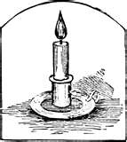
In fond memory of Irene Ellis and Dolly Boundy, two long-time Older Adult Program members who will be missed.

*OCTOBER LUNCH AT
TUCKER’S MARKET PLACE


Tucker’s is a pleasant place to enjoy a tasty luncheon buffet for a reasonable price. Good food, good value! TTC directions: Catch the #34 Eglinton eastbound bus to Warden Avenue. Cross over Eglinton to the north-west corner. Tucker’s is just a short walk away. Look for the big Tucker’s Marketplace sign. This lunch outing is limited to fifteen participants only. Please call the centre, 416 392-0511, ext 0, and reserve your spot, as a reservation will be made for the group

Date: Wednesday, Oct. 6
Time: 12:30 p.m.
Cost: Please pay for your own food.

Senior’s price: $10.15 (includes coffee/tea, soft drink, but does not include tip). Registration closes Monday, October 4, or when fully booked.

MEET KIM, OUR 3RD YEAR RYERSON NURSING PLACEMENT STUDENT

It’s fall and time to meet our 3rd Year Nursing Placement student, Kim. Kim will be at the Centre every Tuesday and Wednesday until early December. Be sure to check out her programs which will focus on health and wellness topics, such as sleep and nutrition. Do you have suggestions for topics? Please let Kim know what you would like to learn more about. Light refreshments will be served. No need to register, just drop in!

Date: Tuesday, Sept. 14
Time: 2:00 p.m.
Cost: FREE!

MORE 50 + PROGRAMS

*ONTARIO SCIENCE CENTRE
IMAX FILM
Check out this amazing IMAX film about the Hubbell Telescope at the Ontario Science Centre. TTC Directions: Catch a #34 Eglinton Bus to Don Mills Road. Get off and walk a block south to the Science Centre. Please call 416 392-0511. ext. 0, to reserve a spot. Registration is limited to ten participants.
Date: Thursday, Sept. 2
Time: 1:00 p.m.
Cost: $9.00 senior’s admission price
Please meet Blythe inside the main lobby of the Ontario Science Centre after 12:30 p.m., and pick up your IMAX film ticket from her.

*OSTEO EXERCISE CLASS
MONDAYS and WEDNESDAYS

Osteo Exercise is led by a very experienced instructor, Yvonne, and composed of gentle resistance/strength training and postural exercises using small weights or stretch bands. Sign up for a complete session, or just drop-in ($5.00 per class, depending on space availability). Make Osteo Exercise a weekly component of your fitness routine and keep your bones strong and healthy.

Date: Mondays - Sept. 13 - Oct. 25
(6 classes, no class on Oct. 11)
Wednesdays - Sept. 8 - Oct. 27 (8 classes)
Time: 1:30 – 2:30 p.m.
Cost:
Mondays - $30.00 CECC members,
$40.00 non-members
Wednesdays - $40.00 CECC members,
$50.00 non-members

*COFFEE CAFÉ

Join us for a relaxing social hour to enjoy coffee together at a local coffee bar. Coffee Café meets at the times indicated below and is free unless otherwise indicated. Please register when the activity is indicated with an *. Registration closes the Monday before the event and participation is limited.
*Date: Wednesday, Sept. 29 – JEDD’S Frozen Custard Café, 2470 Yonge St., west side of Yonge, near Erskine Avenue. Meet at the café at 1:00 p.m. Please pay for your own refreshments.
*Date: Tuesday, Oct. 26 – Organic Bakery and Café, 3189 Yonge St., 2 blocks north of Lawrence Avenue on the east side at Ranleigh Avenue. Meet at the café at 11:00 a.m. Please pay for your own refreshments.

MORE 50 + PROGRAMS
21
The bi-monthly 50+ Calendar will provide full details on these activities for adults 50+. View it on-line at www.centraleglinton.com or pick up a calendar at the Centre. Calendars are mailed to CECC members.

*THE COFFEE CAFÉ- meets once a month to visit a local coffee bar.

CLOSED CAPTIONED MOVIES - For people who enjoy films but may have some difficulty in hearing. Movies are all recent releases and begin at 1:30 p.m. sharp. The cost is $2.00 for refreshments.

*PLAYS & STORIES: Join us twice a month on Fridays to read out loud to each other. FREE!

CONVERSATIONAL FRENCH – Drop in on alternate Mondays at 3:00 p.m. for casual and fun French conversation with Madame Bui. FREE!

MOVIE MATINEE – New video releases are shown two or three times every month at 1:30 p.m. Cost: $2.00 for refreshments.

CURRENT EVENTS – This lively drop-in group meets every Monday at 1:00 p.m. FREE!

MONTHLY BIRTHDAY CLUB & CURRENT EVENTS - Join us on the last Monday of the month for lively discussion, tea, coffee and birthday cake. Cost: $2.00

*LUNCH AND LEARN – Informative lectures are held once or twice a month. FREE unless otherwise indicated.

*LUNCHEONS – We dine our way around the city visiting various restaurants.

*TORONTO OUTINGS - Once or twice a month we venture out to explore our exciting City.

*BUS TRIPS - Seasonal bus trips to a variety of destinations. Prices vary.

*FITNESS – We offer a great variety of 50+ fitness programs at reasonable prices. Chair Exercises are FREE! Check 50 + Calendar for full details.

CINE-CLUB - We view interesting foreign, art & film festival movies once a month @ 2:00 p.m. FREE!

*SCRABBLE – Drop in twice a month for brain exercise and good companionship. See the 50+ Calendar for dates and time. Free!

COMPUTER LAB COURSES FALL 2010
22

To register, please phone 416-392-0511, ext. 0, or come into the Centre.
TWO SESSIONS TO CHOOSE FROM!
Please note: A minimum number of registrants is required to run each course.

INTRODUCTION TO WINDOWS
“If you’re new to computers, this is the class for you.”
Starting and logging on; using the Mouse. Starting a program; understanding a Window. Using menus & toolbars; entering text; saving files. Understanding folders and files. Using My Computer.
Date: Mondays, Session I: Sept. 27 – Oct. 25 (4 classes, no class Oct. 11) OR
Session II: Nov. 1 – Nov. 22 (4 classes)
Time: 10:00 a.m. – 12:00 noon
Cost: $60.00 members, $65.00 non-members (per session)

INTERNET COURSE “The Internet: Worlds to Explore!”
Pre-requisite: Introduction to the Personal Computer or equivalent experience

Introduction to the Internet. Surfing and news blogs. Chatting. Internet phone and entertainment (world radio & TV). Shopping. Free software. Downloading & printing. Searching the ‘net (the proper procedures). Installing free multimedia tools. Internet e-mail set up and use. Finding free tools for security and computer safety.
Date: Tuesdays, Session I: Sept. 28 – Oct. 26 (5 classes) OR Session II: Nov. 2 – Nov. 30 (5 classes)
Time: 10:00 a.m. – 12:00 noon
Cost: $70.00 members, $75.00 non-members (per session)

SMARTPHONE TECHNOLOGY: Introduction NEW!
Pre-requisite: Introduction to the Personal Computer or equivalent experience.

Smartphones are as complicated as computers: internet ready, GPS equipped, cameras, Wi-Fi, world phones. Come to this 2-part tutorial and learn all you need to know about Smartphone technology.
Date: Session I: Wednesday & Thursday, Oct. 27 & 28 OR Session II: Wednesdays, Dec. 1 & 8
Time: 10:00 a.m. – 12:00 noon
Cost: $25.00 members, $30.00 non-members (per session)

INTRODUCTION TO SOCIAL NETWORKING: Start Tweeting!
Introduction to the Personal Computer Social Networking Services (Facebook, Twitter, Flock, TweetDeck, Microsoft Live Messenger, Skype, Blogs, Fliker) and others. Joining a Social Networking Service; sharing on Social Networks. Individual projects. Using Social Networking Media Programs. Linking to Social Networks. Sharing blog content with your Network. Creating and uploading media to share. Completing individual projects and review.
Date: Wednesdays, Session I: Sept. 29 – Oct. 20 (4 classes) OR Session II: Nov. 3 – Nov. 24 (4 classes)

Time: 10:00 a.m. – 12:00 noon
Cost: $60.00 members, $65.00 non-members (per session)

DIGITAL PHOTOGRAPHY Photograph Correction & Free Tools
“Here’s where you can learn to repair old photographs or touch up a new digital photograph.”
Pre-requisite: Introduction to the Personal Computer or equivalent experience
Introduction to gamma & digital colour. Transferring digital photos to the computer. Where to get free tools. Using a scanner (bring a picture to scan). Photoshop and Paintshop Pro. Colour & the computer. Project: repair a personal photo.
Date: Thursdays, Session I: Sept. 30 – Oct. 21 (4 classes) OR
Session II: Nov. 4 – Dec. 2 (4 classes, no class Nov. 11)
Time: 10:00 a.m. – 12:00 noon
Cost: $60.00 members, $65.00 non-members (per session)

Reginald Cottle received Webmaster Applications certification from Digital Media Studios in 1997 and 3CISSP certification in internet security granted by Watchfire in 2007. A trainer as well as past project manager for a youth internet HRDC training program, he also holds among other certifications, one in hospitality from The Royal Bank and in programming. His community involvement for almost a decade now focuses on the growth of the individual within the community with courses to introduce others to the usefulness of the computer. He teaches at a Toronto-based community centre and works within the computer field.

WE THANK OUR ADVERTISERS FOR THEIR SUPPORT!
23

2

 | Patrick Rocca B.A.A.  Broker,  McGillivray Award  Bus: (416) 322-8000 Fax: (416) 322-8800  BOSLEY REAL ESTATE  290 Merton Street Toronto, Ont. M4S 1A9  email: mail@patrickrocca.com www.patrickrocca.com
Andrea Cleaver  NATUROPATHIC DOCTOR (ND)  Tel.: 416.273.5054 Email: nd@andreacleaver.com  Web: www.andreacleaver.com  Fertility, Women’s Health & Pediatric Care | CIBC CIBC WOOD GUNDY  CIBC World Markets Inc.  One City Centre Drive  CHRISTOPHER ANDERSON Suite 1100  B.SC., F.C.S.I, Vice President Mississauga, ON. L5B 1M2  Investment Advisor  chris.anderson@cibc.ca Tel: 905-897-3715  CIBC Wood Gundy is a division of Fax: 905-897-0743  CIBC World Markets Toll free: 1-800-567-5889
BRIAN CHONG, B.B.A., FMA, C.A.  Investment Advisor  DUNDEE SECURITIES CORPORATION  100 Commerce Valley Drive, Ste. 408  Thornhill, Ontario L3T 7W3  Phone: 905-763-2339, Ext. 27  Cell: 416-738-4608    Fax: 416-946-1822  bchong@dundeesecurities.com www.dundeewealth.com/-bchong | Scotiabank  Nino Pasquariello, FMA, Manager,  Yonge & Eglinton  - Yonge Street  Toronto, Ontario M4S 2C7  Tel: 416-932-3791 Fax: 416-932-3166  Website: www.scotiabank.com
  Workshops Activities Refreshments  Go to www.munchandlearn.ca  Register Online |   Workshop Activities Refreshments  Go to www.munchandlearn.ca  Register Online
YOUR AD HERE | NEWSLETTER ADVERTISING RATES  1 issue $ 50.00  2 issues $ 75.00  3 issues $ 100.00  4 issues $ 115.00

CENTRAL EGLINTON COMMUNITY CENTRE BOARD OF MANAGEMENT

Susan Innes, Chair Wilmar Kortleever, Vice-Chair Larry Binns, Treasurer
Kelly Beale Joanne Rice David Shtern Abdul Versi Councillor Michael Walker, Appointed Member

24

28

MEMBERSHIP

CECC memberships are available, renewable annually (and please note, memberships are non-refundable). With CECC membership, you have voting privileges at the Annual General Meeting and receive the CECC newsletter quarterly. Family members can attend all drop-ins for free. Additionally, Older Adult/50+ members receive the OA/50+ Program Calendar six times per year. CECC membership is required for registration in FRC and day camp programs, and entitles members to a discount in the OA/50+ and Community programs. New members are always welcome. Join us today!

Family (Including Toy Library) $35.00 per year
Individual $25.00 per year
50+/Older Adult $25.00 per year
50+/Older Adult Couple $30.00 per couple/year
Groups $75.00 per year

MISSION STATEMENT

Central Eglinton Community Centre provides programs and services to meet the diverse and changing needs of our community. We are committed to:

High quality programming

Financial, physical and social accessibility

Volunteerism

Providing opportunities for community participation.
We encourage the development of a forum for individuals to share their concerns and ideas, and to work together in the resolution of community issues within an environment that fosters dignity and equity.
Central Eglinton Community Centre Staff
CENTRAL EGLINTON COMMUNITY CENTRE
160 Eglinton Avenue East, Toronto, Ontario M4P 3B5

Susan Kee Executive Director
Regina Chan Finance Manager
Johanne Letlow Evening/Sat.
Receptionist
Nancy Lyon Program & Resource
Development Manager
Mary Neeson Volunteer Co-ordinator
Denise Pivott Clerical Assistant
Blythe Runnett Older Adult Program
Co-ordinator
Leanna Tuba Family Resource Centre
Co-ordinator

REFUND POLICY
There are no refunds for withdrawals from any programs (including classes, workshops, luncheons, bus trips, theatre tickets and outings). In lieu of refunds, a credit voucher, less a 15% administrative fee, redeemable for a twelve-month period, will be issued. No credit vouchers will be issued for pre-paid event tickets (theatre tickets, bus trips, luncheons, etc). Any refunds granted will be at the Program Manager’s discretion and subject to a 15% administrative fee. No refunds or credits will be issued for Centre memberships. Any cheque returned by the bank for any reason will be subject to a $25.00 charge.

.

